
RAMSEUR FAMILY DENTISTRY
Jennifer K. Hardesty, DDS, PA
153 N. Brady St, Ramseur NC, 27316
Phone: (336) 824-8300 Fax: (336) 824-6556
New Patient Package Information
To Our New Patients:
Thank you for placing your trust in Ramseur Family Dentistry for your dental health.
Attached you will find forms that must be completed prior to your appointment.
If you are unable to have these forms completed in their entirety by the date of your visit, please plan to arrive at least 20 minutes early.
We try very hard to ensure that all our patients are seen on time. Your assistance with completing your paperwork before hand or arriving early will assure we can keep the office on time.
Should you have any questions prior to your appointment please feel free to contact us at
(336) 824-8300
We look forward to meeting you!
Sincerely,
Jennifer K. Hardesty, DDS, PA and Staff
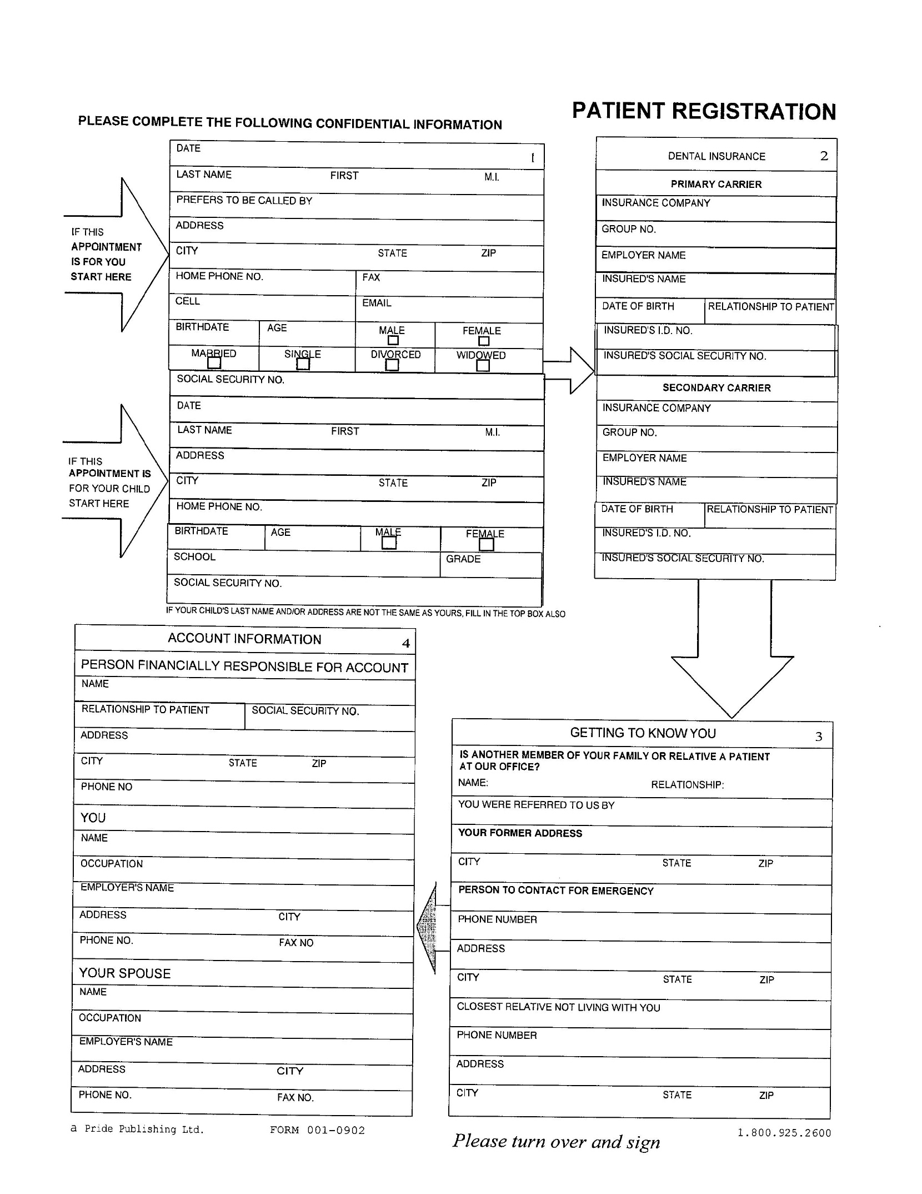
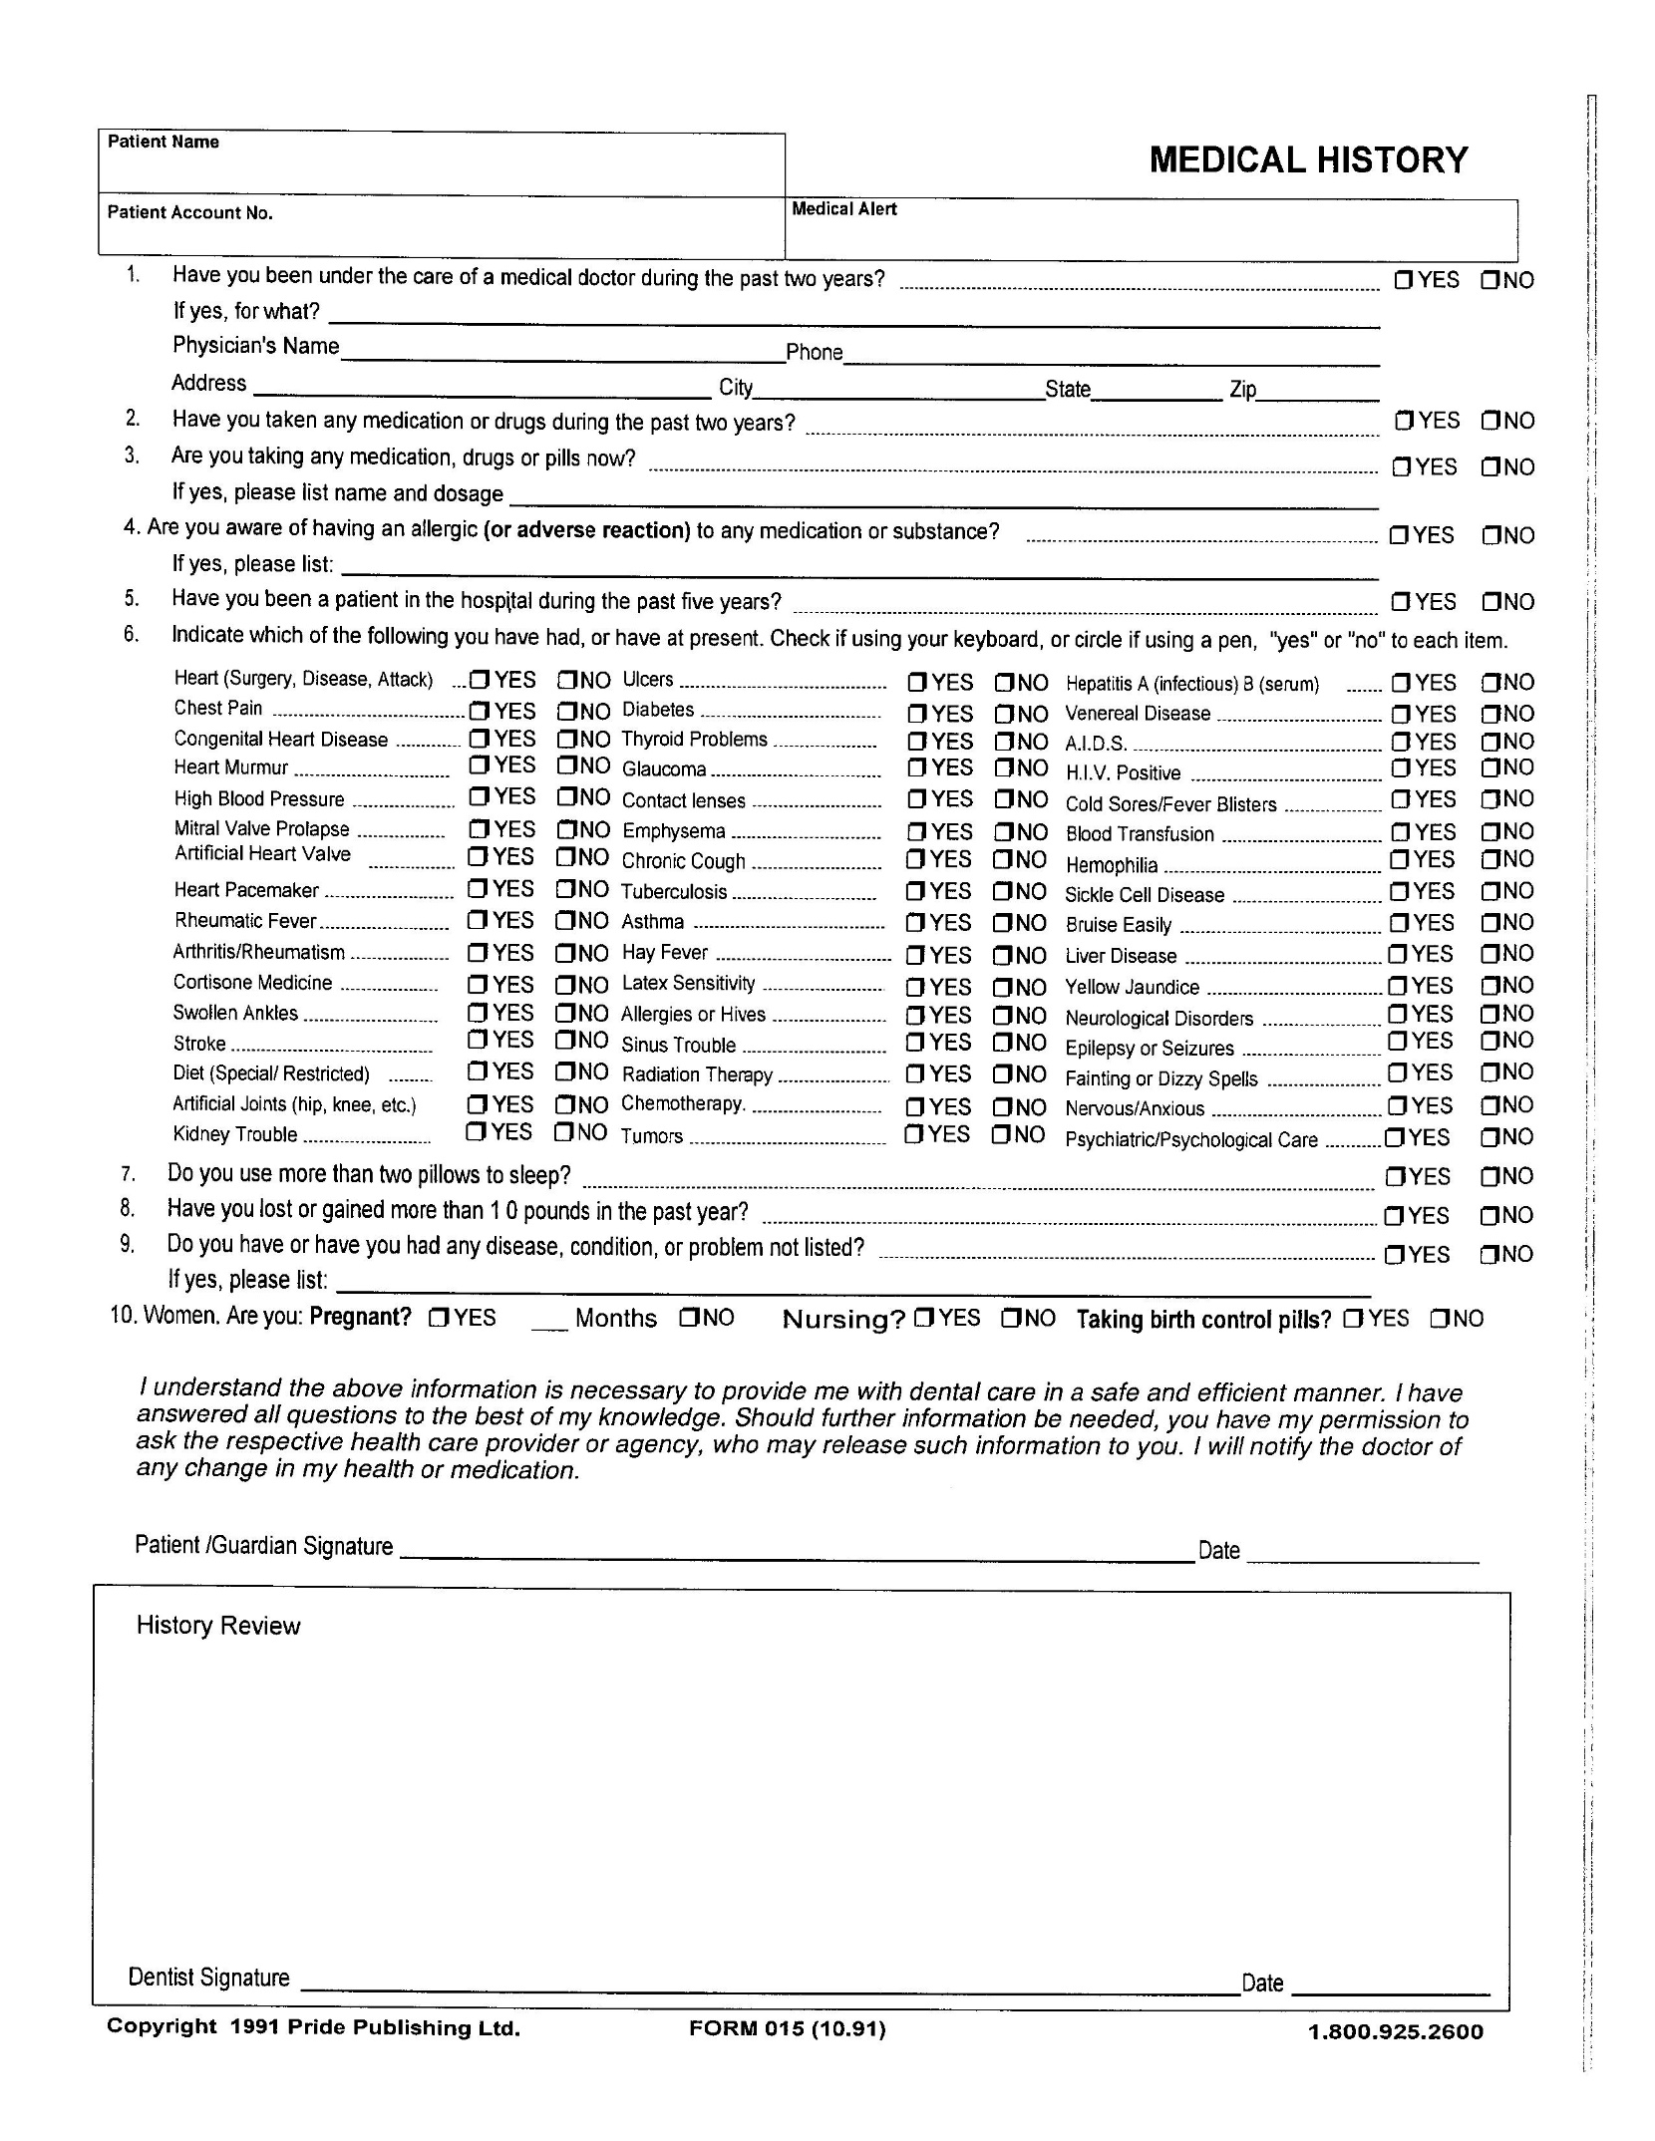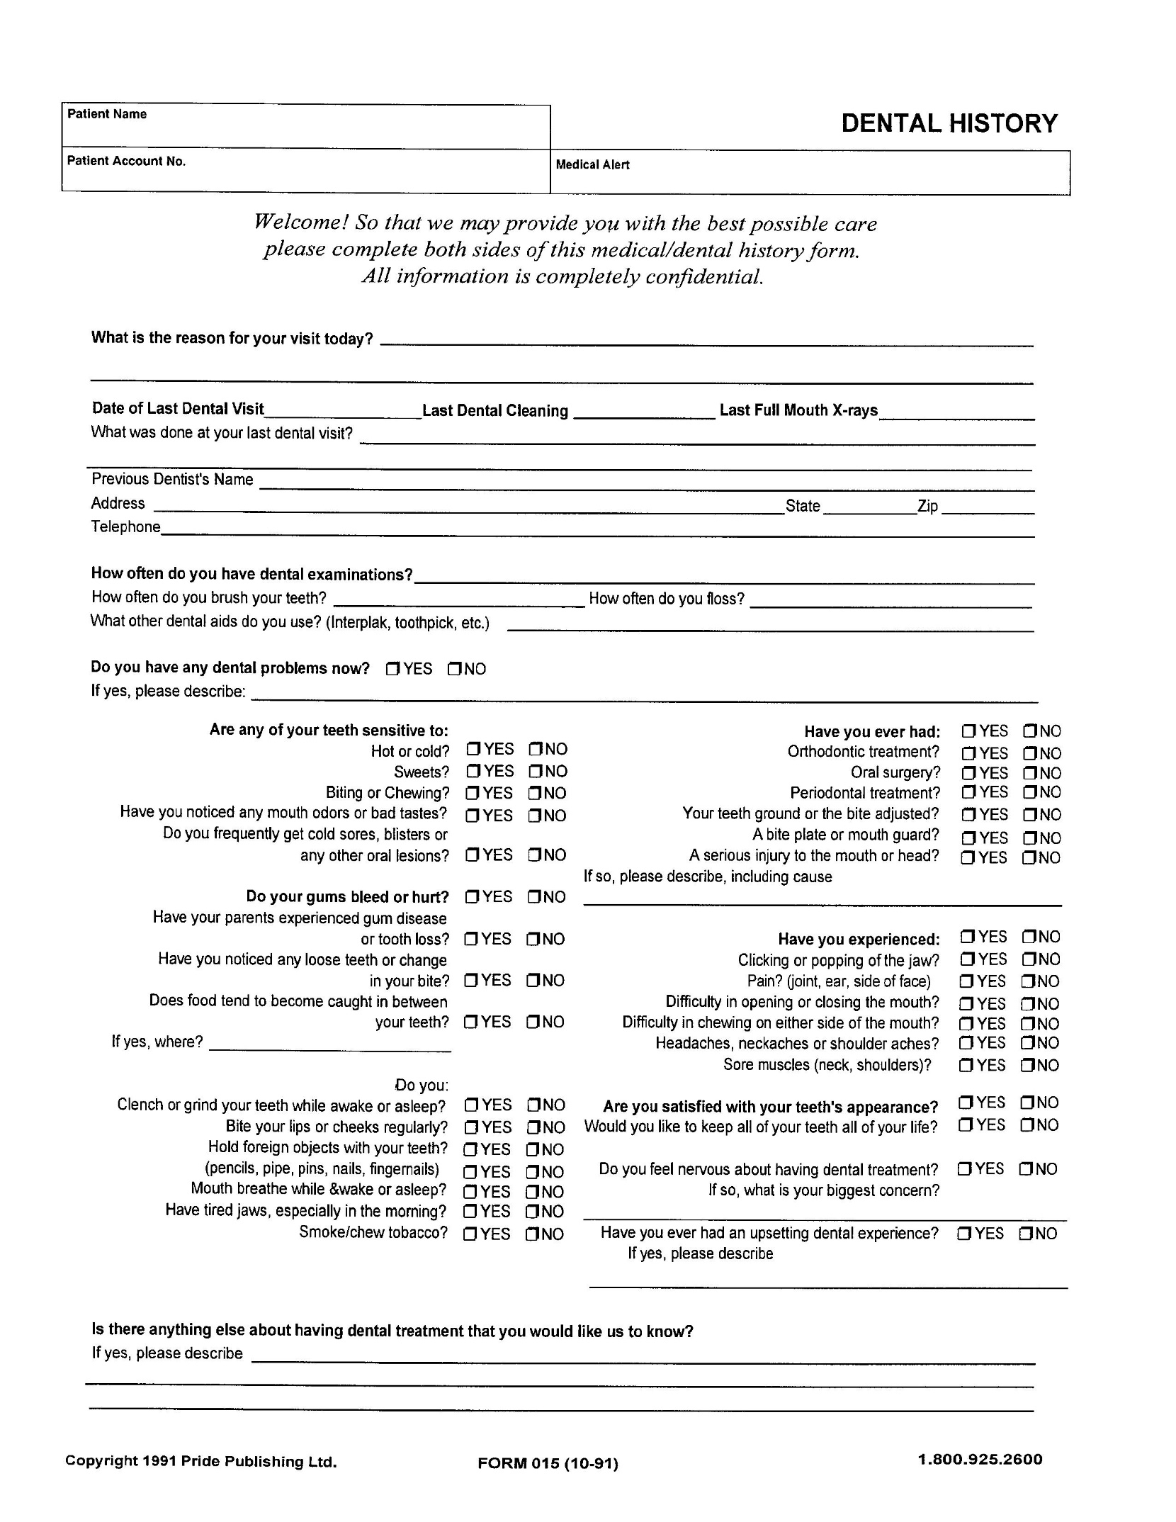

CONSENT FOR TREATMENT
- I hereby authorize doctor or designated staff to take x-rays, study models, photographs, and other diagnostic aids deemed appropriate by doctor to make a thorough diagnosis of (name of patient) ___________________________________'s dental needs.
- Upon such diagnosis, I authorize doctor to perform all recommended treatment mutually agreed upon by me and to employ such assistance as required to provide proper care.
- I agree to the use of anesthetics, sedatives and other medication as necessary. I fully understand that using anesthetic agents embodies certain risks. I understand that I can ask for a complete recital of any possible complications.
- I give consent to the doctor's or designated staff's use and disclosure of any oral, written or electronic health records that are individually identifiable as mine for the purpose of carrying out my treatment, payment and health care operations. I understand that only the minimum amount of information necessary to provide quality care will be used or disclosed and that a notice fully outlining the protection of my personal health information is available.
- I agree to be responsible for payment of all services rendered on my behalf or my dependents. I understand that payment is due at the time of service unless other arrangements have been made. In the event payments are not received by agreed upon dates, I understand that a lh% late charge (18% APR) may be added to my account. If required, I also understand a check of my credit history may be made.
Patient's Signature ______________________________ Date ________________

Parent/Responsible Party's Signature ________________________________

Relationship to Patient ______________________________

Witness _______________________________

Dental Insurance Disclosure
If you have dental insurance we will be happy to file your claims as a courtesy to you. If after a period of 30 days the office has not received payment for services you will be responsible for payment in full. If your insurance does not cover treatments other than cleanings, full payment is expected when services are rendered.
On the day of you appointment, you are responsible for paying any applicable deductible and any additional sum owing on your account. this will be based on the type of appointment, your insurance, and our office policies. Our office policy is based on the fact that your insurance involves a legal contract between you and your insurance company.
We advise you to become familiar with your benefits. Most dental insurance plans call for deductibles, yearly maximums, procedural co-payments and limitations. We will be happy to assist you in determining the terms of coverage on your insurance policy if you are not already familiar with them. However, information provided to you by our office staff does not guarantee payment from your insurance carrier.
We are currently in-network with two carriers. Ask the front desk staff if your carrier is one of our network partners.
If you need to make payment arrangements, please do so prior to your appointment or within the 10-day billing period provided on your statement.
We have reserved a special time just for you. We intend to be on time for our patients and we ask that yo extend the same courtesy to us. If you are running late or find you can not make your appointment we ask that you call or you will be assessed a missed or late appointment fee.
Again, any charges that your insurance does not pay will become your full responsibility.
Date: ______________ Signed: _________________________
To Our Patients:
Thank you for your interest in your dental health and the appointment you have scheduled. We appreciate the confidence you have placed in us. Because we take great pride in providing our patients with the highest in quality dental care. We have created this medical and CDC disclosure.
In an effort to ensure your experience and dental care are nothing short of the best that can be offered. We need to know if you have or have ever been treated for the following conditions. The conditions as listed would require you to take a preventative antibiotic prior to your dental visit. Knowing of these conditions in advance, we can ensure that you have reminders and the medication needed to pre-medicate.
- Artificial Heart Valves.
- A history of Infective Endocarditis.
- Certain specific, serious congenital (present at birth) heart conditions, including:
> unrepaired or incompletely repaired cyanotic congenital heart disease, including those with palliative shunts and conduits.
> a completely repaired congenital heart defect with prosthetic material or device, whether placed by surgery or by catheter intervention, during the first six months after the procedure.
> any repaired congenital heart defect with residual defect at the site or adjacent to the site of a prosthetic patch or a prosthetic device.
> a cardiac transplant that develops a problem in a heart valve.
These recommendations are through the American Heart Association and were updated as of October 2007. These updates were taken and written exactly as they were presented on the ADA website located at www.ada.org.
The old guidelines stated that the following conditions would be cause for a patient to pre-medicate:
> Mitral valve prolapse
> Rheumatic heart disease
> Bicuspid valve disease
> Calcified aortic stenosis
* However, scientists have found no compelling evidence that taking antibiotics prior to a dental procedure when the patient has the conditions listed, underlined above, will help to prevent IE in those patients who are at risk of developing a heart infection. *
We also want to take this opportunity to reassure you that nothing is more important than the cleanliness of our office. We observe controls as required by the CDC (Center for Disease Control) insuring that all dental instruments are completely disinfected and sterilized before each use. We use a steam autoclave machine in order to sterilize all instruments and comply with infection control. We will be happy to answer any questions you may have in conjunction with our strilization and infection control procedures.
Date: _____________ Signed: _________________________________

HIPAA Notice of Privacy Practices

Ramseur Family Dentistry
THIS NOTICE DESCRIBES HOW MEDICAL INFORMATION ABOUT YOU MAY BE USED AND DISCLOSED AND HOW YOU CAN GET ACCESS TO THIS INFORMATION. PLEASE REVIEW IT CAREFULLY.
We are required by law to maintain the privacy of protected health information, to provide individuals with notice of our legal duties and privacy practices with respect to protected health information, and to notify affected individuals following a breach of unsecured protected health information. We must follow the privacy practices that are described in this Notice while it is in effect. This Notice takes effect January 1, 2014, and will remain in effect until we replace it.
We reserve the right to change our privacy practices and the terms of this Notice at any time, provided such changes are permitted by applicable law, and to make new Notice provisions effective for all protected health information that we maintain. When we make a significant change in our privacy practices, we will change this Notice and post the new Notice clearly and prominently at our practice location, and we will provide copies of the new Notice upon request.
You may request a copy of our Notice at any time. For more information about our privacy practices, or for additional copies of this Notice, please contact us using the information listed at the end of this Notice.

HOW WE MAY USE AND DISCLOSE HEALTH INFORMATION ABOUT YOU
We may use and disclose your health information for different purposes, including treatment, payment, and health care operations. For each of these categories, we have provided a description and an example. Some information, such as HIV-related information, genetic information, alcohol and/or substance abuse records, and mental health records may be entitled to special confidentiality protections under applicable state or federal law. We will abide by these special protections as they pertain to applicable cases involving these types of records.
Treatment. We may use and disclose your health information for your treatment. For example, we may disclose your health information to a specialist providing treatment to you.
Payment. We may use and disclose your health information to obtain reimbursement for the treatment and services you receive from us or another entity involved with your care. Payment activities include billing, collections, claims management, and determinations of eligibility and coverage to obtain payment from you, an insurance company, or another third party. For example, we may send claims to your dental health plan containing certain health information.
Healthcare Operations. We may use and disclose your health information in connection with our healthcare operations. For example, healthcare operations include quality assessment and improvement activities, conducting training programs, and licensing activities.
Individuals Involved in Your Care or Payment for Your Care. We may disclose your health information to your family or friends or any other individual identified by you when they are involved in your care or in the payment for your care. Additionally, we may disclose information about you to a patient representative. If a person has the authority by law to make health care decisions for you, we will treat that patient representative the same way we would treat you with respect to your health information.
Disaster Relief. We may use or disclose your health information to assist in disaster relief efforts.
Required by Law. We may use or disclose your health information when we are required to do so by law.
Public Health Activities. We may disclose your health information for public health activities, including disclosures to: Prevent or control disease, injury or disability;
- Report child abuse or neglect;
- Report reactions to medications or problems with products or devices;
- Notify a person of a recall, repair, or replacement of products or devices;
- Notify a person who may have been exposed to a disease or condition; or
- Notify the appropriate government authority if we believe a patient has been the victim of abuse, neglect, or domestic violence.
National Security. We may disclose to military authorities the health information of Armed Forces personnel under certain circumstances. We may disclose to authorized federal officials health information required for lawful intelligence, counterintelligence, and other national security activities. We may disclose to correctional institution or law enforcement official having lawful custody the protected health information of an inmate or patient.
Secretary of HHS. We will disclose your health information to the Secretary of the U.S. Department of Health and Human Services when required to investigate or determine compliance with HIPAA.
Worker's Compensation. We may disclose your PHI to the extent authorized by and to the extent necessary to comply With laws relating to worker's compensation or other similar programs established by law.
Law Enforcement. We may disclose your PHI for law enforcement purposes as permitted by HIPAA, as required by law, or in response to a subpoena or court order.
Health Oversight Activities. We may disclose your PHI to an oversight agency for activities authorized by law. These oversight activities include audits, investigations, inspections, and credentialing, as necessary for licensure and for the government to monitor the health care system, government programs, and compliance with civil rights laws.
Judicial and Administrative Proceedings. If you are involved in a lawsuit or a dispute, we may disclose your PHI in response to a court or administrative order. We may also disclose health information about you in response to a subpoena, discovery request, or other lawful process instituted by someone else involved in the dispute, but only if efforts have been made, either by the requesting party or us, to tell you about the request or to obtain an order protecting the information requested.
Research. We may disclose your PHI to researchers when their research has been approved by an institutional review board or privacy board that has reviewed the research proposal and established protocols to ensure the privacy of your information.
Coroners, Medical Examiners, and Funeral Directors. We may release your PHI to a coroner or medical examiner. This may be necessary, for example, to identify a deceased person or determine the cause of death. We may also disclose PHI to funeral directors consistent with applicable law to enable them to carry out their duties.
Fundraising. We may contact you to provide you with information about our sponsored activities, including fundraising programs, as permitted by applicable law. If you do not wish to receive such information from us, you may opt out of receiving the communications.

Other Uses and Disclosures of PHI
Your authorization is required, with a few exceptions, for disclosure of psychotherapy notes, use or disclosure of PHI for marketing, and for the sale of PHI. We will also obtain your written authorization before using or disclosing your PHI for purposes other than those provided for in this Notice (or as otherwise permitted or required by law). You may revoke an authorization in writing at any time. Upon receipt of the written revocation, we will stop using or disclosing your PHI, except to the extent that we have already taken action in reliance on the authorization.

Your Health Information Rights
Access. You have the right to look at or get copies of your health information, with limited exceptions. You must make the request in writing. You may obtain a form to request access by using the contact information listed at the end of this Notice. You may also request access by sending us a letter to the address at the end of this Notice. If you request information that we maintain on paper, we may provide photocopies. If you request information that we maintain electronically, you have the right to an electronic copy. We will use the form and format you request if readily producible. We will charge you a reasonable cost-based fee for the cost of supplies and labor of copying, and for postage if you want copies mailed to you. Contact us using the information listed at the end of this Notice for an explanation of our fee structure.
If you are denied a request for access, you have the right to have the denial reviewed in accordance with the requirements of applicable law.
Disclosure Accounting. With the exception of certain disclosures, you have the right to receive an accounting of disclosures of your health information in accordance with applicable laws and regulations. To request an accounting of disclosures of your health information, you must submit your request in writing to the Privacy Official. If you request this accounting more than once in a 12month period, we may charge you a reasonable, cost-based fee for responding to the additional requests.
Right to Request a Restriction. You have the right to request additional restrictions on our use or disclosure of your PHI by submitting a written request to the Privacy Official. Your written request must include (1) what information you want to limit, (2) whether you want to limit our use, disclosure or both, and (3) to whom you want the limits to apply. We are not required to agree to your request except in the case where the disclosure is to a health plan for purposes of carrying out payment or health care operations, and the information pertains solely to a health care item or service for which you, or a person on your behalf (other than the health plan), has paid our practice in full.
Alternative Communication. You have the right to request that we communicate with you about your health information by alternative means or at alternative locations. You must make your request in writing. Your request must specify the alternative means or location, and provide satisfactory explanation of how payments will be handled under the alternative means or location you request. We will accommodate all reasonable requests. However, if we are unable to contact you using the ways or locations you have requested we may contact you using the information we have.
Amendment. You have the right to request that we amend your health information. Your request must be in writing, and it must explain why the information should be amended. We may deny your request under certain circumstances. If we agree to your request, we will amend your record(s) and notify you of such. If we deny your request for an amendment, we will provide you with a written explanation of why we denied it and explain your rights.
Right to Notification of a Breach. You will receive notifications of breaches of your unsecured protected health information as required by law.
Electronic Notice. You may receive a paper copy of this Notice upon request, even if you have agreed to receive this Notice electronically on our Web site or by electronic mail (e-mail).
Questions and Complaints
If you want more information about our privacy practices or have questions or concerns, please contact us.
If you are concerned that we may have violated your privacy rights, or if you disagree with a decision we made about access to your health information or in response to a request you made to amend or restrict the use or disclosure of your health information or to have us communicate with you by alternative means or at alternative locations, you may complain to us using the contact information listed at the end of this Notice. You also may submit a written complaint to the U.S. Department of Health and Human Services. We will provide you with the address to file your complaint with the U.S. Department of Health and Human Services upon request.
We support your right to the privacy of your health information. We will not retaliate in any way if you choose to file a complaint with us or with the U.S. Department of Health and Human Services.
Our Privacy Official: Dr. Jennifer K. Hardesty
Telephone: (336) 824-8300 Fax: (336) 824-6556
Address: 153 N. Brady St. Ramseur, NC 27316
E-mail: info@ramseurfamilydentistry.com
Reproduction of this material by dentists and their staff is permitted. Any other use, duplication or distribution by any other party requires the prior written approval of the American Dental Association. This material is educational only, does not constitute legal advice, and covers only federal, not state, law. Changes in applicable laws or regulations may require revision. Dentists should contact their personal attorneys for legal advice pertaining to HIPAA compliance, the HITECH Act, and the U.S. Department of Health and Human Services rules and regulations.
0 2010, 2013 American Dental Association. All Rights Reserved.

HIPAA Notice of Privacy Practices

Ramseur Family Dentistry
Acknowledgement of Receipt of HIPAA Policies and Procedures
I have received and reviewed a copy of our dental practice's privacy, security and breach notification policies and procedures.
I understand that I should ask our dental practice's Privacy Official if I have any questions about these policies and procedures.
Print Name: _____________________________________________________

Signature: ______________________________________________________

Date: ______________________________

Reproduction of this material by dentists and their staff is permitted. Any other use, duplication or distribution by any other party requires the prior written approval of the American Dental Association. This material is for general reference purposes only and does not constitute legal advice. It covers only HIPAA, not other federal or state law. Changes in applicable laws or regulations may require revision. Dentists should contact qualified legal counsel for legal advice, including advice pertaining to HIPAA compliance, the HITECH Act, and the U.S. Department of Health and Human Services rules and regulations.
0 2010, 2013 American Dental Association. Ali rights reserved.

Authorization For Release Of Patient Record Information
Name of Patient: _______________ Birthdate: __________________

I hereby authorize the following dental practice:

Name: ______________________________________________

Address: __________________________________________________________

Phone Number: ______________________

To release to Ramseur Family Dentistry and its associates all of my dental records and radiographs. Please send them via one of the following methods:
info@ramseurfamilydentistry.com
Via fax to (336) 824-6556
Via mail: to Ramseur Family Dentistry, 153 N. Brady St, Ramseur, NC 27316
Our contact number is (336) 824-8300 should you have any questions.
Signature: ___________________________ Date: ________________

